Университет ИТМО

Лабораторная работа №6 по Администрированию систем и сетей «Создание WLAN»

Выполнили:

## *Кузнецов Максим Александрович*

Группа*: P34131*

Преподаватель:

## *Афанасьев Дмитрий Борисович*

*Желаемая оценка: 3*

Санкт-Петербург, 2023

## Содержание

Топология 3

Шаг 1. **Настройка основных параметров устройств** 3

Шаг 2. **Настройка параметров проводной сети** 3

Шаг 3. **Настройка параметров точек доступа для входа в сеть** 6

Шаг 4. **Настройка параметров сервисов WLAN** 7

Шаг 5. **Проверка** 8

Вывод 9

# Топология

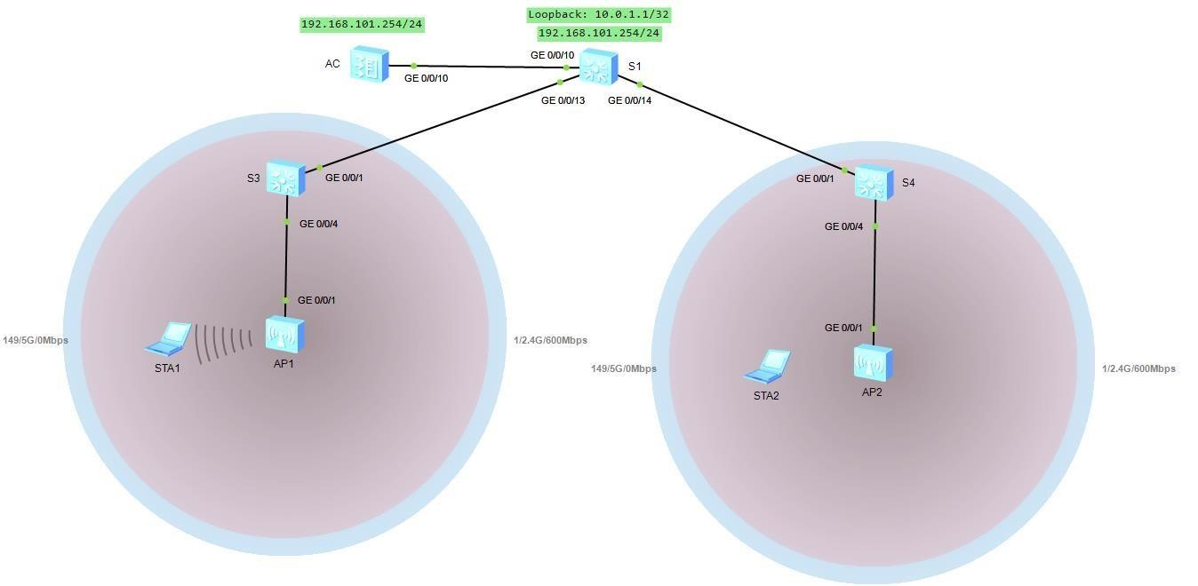

# Шаг 1. Настройка основных параметров устройств

**Отключение ненужных портов:**

[S1]interface GigabitEthernet 0/0/11

[S1-GigabitEthernet0/0/11]shutdown

[S1-GigabitEthernet0/0/11]quit

[S1]interface GigabitEthernet 0/0/12

[S1-GigabitEthernet0/0/12]shutdown

[S1-GigabitEthernet0/0/12]quit

# Шаг 2. Настройка параметров проводной сети

**Команда настройки VLAN:**

[S1]vlan batch 100 101

Info: This operation may take a few seconds. Please wait for a moment...done.

[S1]interface GigabitEthernet 0/0/13

[S1-GigabitEthernet0/0/13]port link-type trunk

[S1-GigabitEthernet0/0/13]port trunk allow-pass vlan 100 101

[S1-GigabitEthernet0/0/13]quit

[S1]interface GigabitEthernet 0/0/14

[S1-GigabitEthernet0/0/14]port link-type trunk

[S1-GigabitEthernet0/0/14]port trunk allow-pass vlan 100 101

[S1-GigabitEthernet0/0/14]quit

[S1]interface GigabitEthernet 0/0/10

[S1-GigabitEthernet0/0/10]port link-type trunk

[S1-GigabitEthernet0/0/10]port trunk allow-pass vlan 100 101

[S1-GigabitEthernet0/0/10]quit

[AC]vlan batch 100 101

Info: This operation may take a few seconds. Please wait for a moment...done.

[AC]interface GigabitEthernet 0/0/10

[AC-GigabitEthernet0/0/10]port link-type trunk

[AC-GigabitEthernet0/0/10]port trunk allow-pass vlan 100 101

[AC-GigabitEthernet0/0/10]quit

[S3]vlan batch 100 101

Info: This operation may take a few seconds. Please wait for a moment...done.

[S3]interface GigabitEthernet 0/0/1

[S3-GigabitEthernet0/0/1]port link-type trunk

[S3-GigabitEthernet0/0/1]port trunk allow-pass vlan 100 101

[S3-GigabitEthernet0/0/1]quit

[S3]interface GigabitEthernet 0/0/4

[S3-GigabitEthernet0/0/4]port link-type trunk

[S3-GigabitEthernet0/0/4]port trunk pvid vlan 100

[S3-GigabitEthernet0/0/4]port trunk allow-pass vlan 100 101

[S3-GigabitEthernet0/0/4]quit

[S4]vlan batch 100 101

Info: This operation may take a few seconds. Please wait for a moment...done.

[S4]interface GigabitEthernet0/0/1

[S4-GigabitEthernet0/0/1] port link-type trunk

[S4-GigabitEthernet0/0/1] port trunk allow-pass vlan 100 to 101

[S4-GigabitEthernet0/0/1]quit

[S4]interface GigabitEthernet0/0/4

[S4-GigabitEthernet0/0/4] port link-type trunk

[S4-GigabitEthernet0/0/4] port trunk pvid vlan 100

[S4-GigabitEthernet0/0/4] port trunk allow-pass vlan 100 to 101 [S4GigabitEthernet0/0/4]quit

**Команда настройки ip-адресов интерфейсов:**

[S1]interface Vlanif 101

[S1-Vlanif101]ip address 192.168.101.254 24

[S1-Vlanif101]quit

[S1]interface LoopBack 0

[S1-LoopBack0] ip address 10.0.1.1 32

[S1-LoopBack0]quit

**Команда настройки DHCP:**

[S1]dhcp enable

Info: The operation may take a few seconds. Please wait for a moment.done.

[S1]ip pool sta

Info:It's successful to create an IP address pool.

IP address pool for STAs

[S1-ip-pool-sta]network 192.168.101.0 mask 24

[S1-ip-pool-sta]gateway-list 192.168.101.254

[S1-ip-pool-sta]quit

[S1]interface Vlanif 101

[S1-Vlanif101]dhcp select global

[S1-Vlanif101]quit

[AC]dhcp enable

Info: The operation may take a few seconds. Please wait for a moment.done.

[AC]ip pool ap Info: It is successful to create an IP address pool.

IP address pool for APs

[AC-ip-pool-ap]network 192.168.100.254 mask 24

[AC-ip-pool-ap]gateway-list 192.168.100.254

[AC-ip-pool-ap]quit

[AC]interface Vlanif 100

[AC-Vlanif100]dhcp select global

[AC-Vlanif100]quit

# Шаг 3. Настройка параметров точек доступа для входа в сеть

**Команды создания группы AP:**

[AC]wlan

[AC-wlan-view]ap-group name ap-group1

Info: This operation may take a few seconds. Please wait for a moment.done. [AC-wlan-apgroup-ap-group1]quit

**Команды создания и настройки профиля регулирующего домена:**

[AC]wlan

[AC-wlan-view]regulatory-domain-profile name default

[AC-wlan-regulate-domain-default]country-code cn

Info: The current country code is same with the input country code.

[AC-wlan-regulate-domain-default]quit

**Команды привязки домена резулируюего домена к группе AP:**

[AC]wlan

[AC-wlan-view]ap-group name ap-group1

[AC-wlan-ap-group-ap-group1]regulatory-domain-profile default Warning: Modifying the country code will clear channel, power and antenna gain configurations of the radio and reset the

AP. Continue?[Y/N]:y

**Команды указания интерфейса-источника на AC для установления туннелей CAPWAP:**

[AC]capwap source interface Vlanif 100

**Команды импорта точек доступа в AC и добавления их в группу AP с именем ap-group1:**

[AC]wlan

[AC-wlan-view]ap auth-mode mac-auth

[AC-wlan-view]ap-id 0 ap-mac 00E0-FCC0-0570

AC-wlan-ap-0]ap-name ap1

[AC-wlan-ap-0]ap-group ap-group1

Warning: This operation may cause AP reset. If the country code changes, it will clear channel, power and antenna gain configurations of the radio, Whether to continue? [Y/N]:y //Введите y для подтверждения.

Info: This operation may take a few seconds. Please wait for a moment.. done.

[AC-wlan-ap-0]quit

[AC-wlan-view]ap-id 1 ap-mac 00E0-FC0D-34D0

[AC-wlan-ap-1]ap-name ap2

[AC-wlan-ap-1]ap-group ap-group1

Warning: This operation may cause AP reset. If the country code changes, it will clear channel, power and antenna gain configurations of the radio, Whether to continue? [Y/N]:y //Введите y для подтверждения.

Info: This operation may take a few seconds. Please wait for a moment.. done. [AC-wlan-ap-1]quit

**Вывод на экран информации о текущей AP:**

[AC-wlan-view]display ap all

Info: This operation may take a few seconds. Please wait for a moment.done. Total AP information: nor : normal [2]

------------------------------------------------------------------------ ID MAC Name Group IP Type State STA Uptime

---------------------------------------------------------------------

0 00e0-fcc0-0570 ap1 ap-group1 192.168.100.14 AP9131DN nor 0 22S

00e0-fc0d-34d0 ap2 ap-group1 192.168.100.59 AP9131DN nor 0 - ----------------------------------------------------------------------- Total: 2

# Шаг 4. Настройка параметров сервисов WLAN

**Команды создания профиля безопасности HCIA-WLAN и настройки политики безопасности:**

[AC-wlan-view]security-profile name HCIA-WLAN

[AC-wlan-sec-prof-HCIA-WLAN]security wpa-wpa2 psk pass-phrase HCIA- Datacom aes [AC-wlan-sec-prof-HCIA-WLAN]quit

**Команды создания профиля SSID HCIA-WLAN:**

[AC]wlan

[AC-wlan-view]ssid-profile name HCIA-WLAN

SSID profile HCIA-WLAN is created.

[AC-wlan-ssid-prof-HCIA-WLAN]ssid HCIA-WLAN

The SSID name is set to HCIA-WLAN.

Info: This operation may take a few seconds, please wait.done.

[AC-wlan-ssid-prof-HCIA-WLAN]quit

**Команды создания профиля VAP HCIA-WLAN:**

[AC]wlan

[AC-wlan-view]vap-profile name HCIA-WLAN

[AC-wlan-vap-prof-HCIA-WLAN]forward-mode direct-forward

[AC-wlan-vap-prof-HCIA-WLAN]service-vlan vlan-id 101

Info: This operation may take a few seconds, please wait.done. [AC-wlan-vap-prof-HCIAWLAN]security-profile HCIA-WLAN

Security profile HCIA-WLAN is bound.

Info: This operation may take a few seconds, please wait.done. [AC-wlan-vap-prof-HCIAWLAN]ssid-profile HCIA-WLAN

SSID profile HCIA-WLAN is bound.

Info: This operation may take a few seconds, please wait.done.

[AC-wlan-vap-prof-HCIA-WLAN]quit

**Команды установки привязки профиля VAP к группе AP и примения конфигурацию профиля VAP HCIA-WLAN к радиомодулю 0 и радиомодулю 1 точек доступа в группе A:**

[AC]wlan

[AC-wlan-view]ap-group name ap-group1

[AC-wlan-ap-group-ap-group1]vap-profile HCIA-WLAN wlan 1 radio all nfo: This operation may take a few seconds, please wait...done. [AC-wlan-ap-group-ap-group1]quit

# Шаг 5. Проверка

**Подключение к WLAN:**

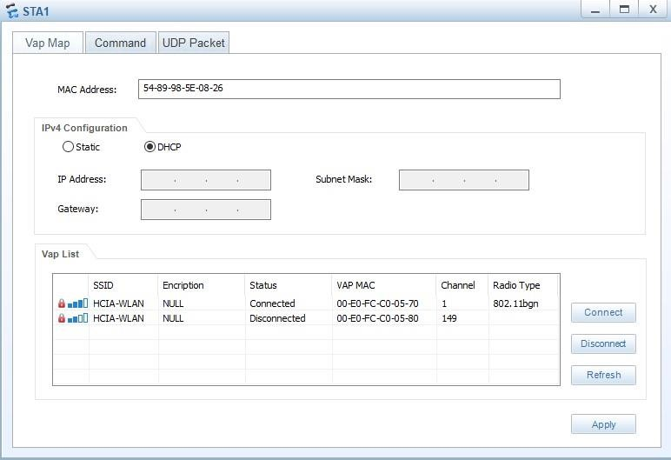

**Проверка связи с S1:**

STA>ping 10.0.1.1

Ping 10.0.1.1: 32 data bytes, Press Ctrl_C to break

From 10.0.1.1: bytes=32 seq=1 ttl=255 time=140 ms

From 10.0.1.1: bytes=32 seq=2 ttl=255 time=157 ms

From 10.0.1.1: bytes=32 seq=3 ttl=255 time=125 ms

From 10.0.1.1: bytes=32 seq=4 ttl=255 time=141 ms

From 10.0.1.1: bytes=32 seq=5 ttl=255 time=140 ms

--- 10.0.1.1 ping statistics ---

5 packet(s) transmitted

5 packet(s) received 0.00% packet loss round-trip min/avg/max = 125/140/157 ms

**Вывод команды “display station all” на AC:**

[AC-wlan-view]display station all

Rf/WLAN: Radio ID/WLAN ID

Rx/Tx: link receive rate/link transmit rate(Mbps) -------------------------------------------------------------------------------

----------------------

STA MAC AP ID Ap name Rf/WLAN Band Type Rx/Tx RSSI VLAN IP a

ddress SSID

-------------------------------------------------------------------------------

----------------------

5489-985e-0826 0 ap1 0/1 2.4G - -/- - 101

192.

168.101.253 HCIA-WLAN

-------------------------------------------------------------------------------

----------------------

Total: 1 2.4G: 1 5G: 0

# Вывод

В процессе выполнения лабораторной работы я получил базовые навыки конфигурации WLAN. По ходу выполнения потребовалось настроить некоторые параметры WLAN, а также создать и настроить профиль WLAN. В результате получилось создать сеть, обеспечивающую мобильность устройств в ней, благодаря двум точкам доступа.